Hoodpopper

Jian Ren

Jir17@pitt.edu

IS2545 - DELIVERABLE 3:

Web Testing with BDD

Issues:

When I install the selenium and built the path I faced a lot of problems, and finally with the help of you, we finally complied it well.

When I firstly practiced the exercises in the class (reddit), I was totally confused about the web stuffs, Such as findElements by many things, like id, name, tagname, and I did not know where to get start, and finally I succeed in doing the first three exercises, but still do not know how to add Junit sentences to the BDD test.

When I do the deliveralbe3, I was confused about the rule of the selenium, such as the "//input[@name='commit']", everytime I was always forget to write the onclick button and made mistakes. When I do the testParse3 ( to check the same length of x = 4 and x=4,) which ignore the whitespace, I created a driver2 but forget to make it at the heroku homepage, and I spent a lot of time to fix it, finally I fixed it today. And still as I noticed in the code, I do not know other method to locate to the 2nd commit button(which is parse button) other than using the xpath.

url:

**https://github.com/renjiandreamore/AwesomeBill/blob/master/deliverable3.java**

Screenshots:

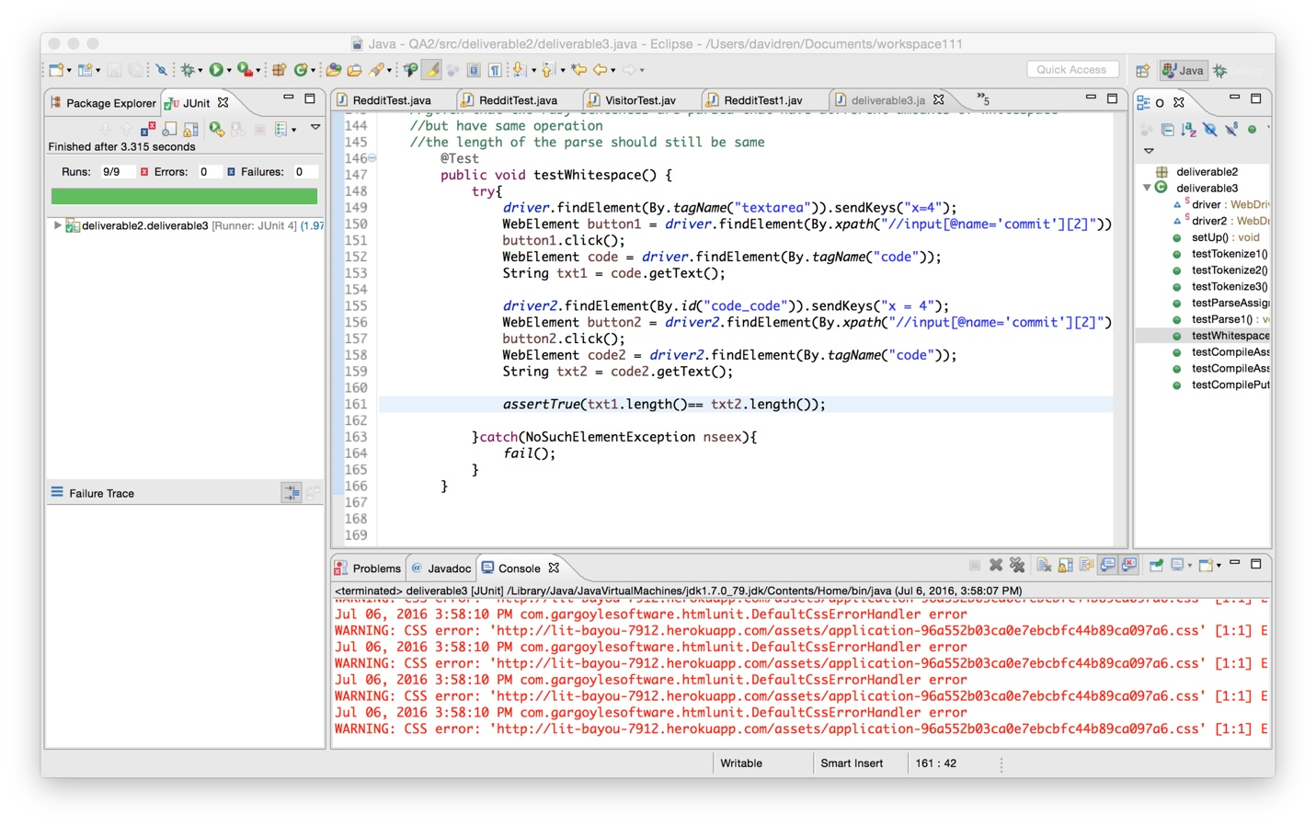

user story and scenarios:

/**

* As a user,

* I would like to see Ruby compilation visualizer using the BDD mode,

* So that I can know what is happening in that compiler.

* **@author** Jian Ren

*

*/

/**User story 1:

* i want to test "tokenization" of the input data

* **@author** davidren

*/

// Scenario 1.1:

// when i typed "x = 3" in the visualizer and click "Tokenize"

// it will contain the tokens "on_ident","on_int", "on_sp", "on_op",etc.

// Senario 1.2:

// if the code i typed is "x = y"

// Then I should NOT see that it contains "on_int"

// Scenario 1.3:

// When a variable is declared, and printed with "puts"

// both the declaration and put statement

// should be same as ":on_ident" .

/**User story 2:

* i want to parse the ruby code

* So I can grasp the ruby's abstract syntax tree

* **@author** davidren

*/

// Scenario 2.1

// given that web page is loaded

// and my code is "x = 3"

// when I click Parse button

// we should see that it contains "x", and "4"

// Scenario 2.2

// Given the Webpage is loaded

// and my code is " puts "hail to pitt!""

// we should see that it both contains "puts" and "hail to pitt!"

//Scenario 2.3

//given that two ruby sentences are parsed that have different amounts of whitespace

//but have same operation

//the length of the parse should still be same

/**User Story 3:

* As a user/Ruby programmer,

* I would like to better understand compilation of my Ruby code,

* So that I can know what the result is after the virtual machine is compiled

* **@author** davidren

*/

// Scenario 3.1

// if my code is "a = 1+2*3/4"

// Then I should see it contains "opt_mult","opt_div","opt_plus"

// Scenario 3.2

// Given that my code is "a = 1+2*3/4"

// When I click Parse button

// Then I should see the size is as expected as : 2;

// Scenario 3.3

// When i typed "2+3" but without puts statement and click compile

// Then I should see the put and operator